|  |
| --- |
| Real Estate Market Analysis NYC |
| Price Index and Median Market Sales Prices Dataset  INFO584  **Group 4**  E-Ching Chiu  Juan Felipe Gonzalez  Almerry Martins  Irina Robin |

Contents

**Executive Summary 2**

Key Findings 2

**Purpose 2**

**Descriptions of Dataset 3**

**Questions & Analyses 4**

**Methodology & Tools Used 5**

**Time Series & Regression Analysis 5**

Price Index Time Series 5

Year over Year Growth Rate 6

Regression Analysis 7

**Visualizations and Dashboards 12**

Median Sales Price over Time 12

Inventory Trend over Time 14

Heat Map - Prices by Neighborhood 16

Dashboard - Top Expensive Neighborhoods - Each Borough and Overall 18

**Limitation of Data 19**

**Stakeholder implicatons, comparisons to other markets, outlook, and conclusion 20**

Implications for Stakeholders 20

Comparison to Other Major Markets 20

Future Outlook 20

Conclusion 21

**References 22**

# 

# **Executive Summary**

New York City Real Estate Market Analysis (2010-2024)

The New York City real estate market has shown significant growth and dynamism over the past 15 years, with distinct trends across its five boroughs.

## **Key Findings**

There has been an overall upward trajectory in median sales prices across all boroughs. Manhattan consistently leads in price, followed by Brooklyn, which has shown the most aggressive growth. The Bronx, Queens, and Staten Island demonstrate steady but more moderate price increase. Brooklyn has emerged as a strong competitor to Manhattan, overtaking Queens as the second most expensive borough. Manhattan exhibits the highest price volatility, with sharp increases and occasional declines. The Bronx, Queens, and Staten Island prices are converging in recent years.

There are significant price disparities within boroughs, particularly evident in the Bronx. High-value neighborhoods in traditionally less expensive boroughs are emerging.

Recent trends show a slight decline in Manhattan prices in most recent years, Continued strong performance in Brooklyn, and steady growth maintained in the Bronx, Queens, and Staten Island.

Analysis based primarily on price data; lacks insights on crucial factors like household income, economic indicators, and neighborhood amenities. Deeper understanding of local factors (transit access, school quality, etc.) needed for comprehensive neighborhood-level analysis.

# **Purpose**

The purpose of this project is to conduct a comprehensive analysis of the New York City real estate market from 2010 to 2024. This analysis aims to understand the trends and dynamics of median sales prices across the city's five boroughs: Manhattan, Brooklyn, Queens, the Bronx, and Staten Island. By examining historical data, price indices, and various economic factors, the project seeks to identify significant patterns and insights that can inform stakeholders about the market's behavior and potential future directions.

The project will explore key metrics such as median sales prices, growth rates, and price volatility within each borough and across different neighborhoods. It will also assess the relationships between price movements in different boroughs and analyze factors contributing to price changes, including economic conditions, housing supply and demand, and local policies.

Utilizing advanced analytical tools and methodologies, including time series analysis and regression models, the project will provide visualizations and dashboards to effectively communicate findings. These insights are intended to help real estate investors, policymakers, and other stakeholders make informed decisions regarding real estate transactions, investments, and development initiatives in New York City.

Additionally, the project will highlight limitations in the current data and suggest areas for further research, such as incorporating additional economic indicators and local factors that influence real estate prices. Through this thorough analysis, the project aims to offer a deeper understanding of the NYC real estate market's past performance and future potential.

# **Descriptions of Dataset**

# 

**The StreetEasy Price Index & Median Recorded Sale Price**

The StreetEasy Price Indices are monthly indices that track changes in resale prices of condo, co-op, townhouse and single-family homes, and are currently available for Manhattan, Brooklyn, and Queens. Each index uses a repeat-sales method of comparing the sales prices of the same properties since January 1995 in Manhattan and January 2005 in Brooklyn and Queens. The repeat-sales method allows each index to better capture changes in home prices by controlling the composition of homes sold in each month. Data on arms-length sales of homes comes from the New York City Department of Finance. (Long, 2017)

The exact middle sales price among all recorded sales prices of homes that closed during the month/quarter/year. In general, median values are more accurate than average values, which may be skewed by price outliers (a few sales that are extremely expensive or extremely inexpensive). In order to consider only arms-length transactions, no foreclosures or sales prices lower than $10,000 were included in this calculation. Records on home sales transactions come from the New York City Department of Finance.

The methodology was introduced in 1963 by Martin Bailey, Richard Muth, and Hugh Nourse (Bailey et al,1963) , and then further developed in the late 1980s by Karl Case and Robert Shiller (Case and Shiller, 1989)**.**

**Date of Dataset Collection**

July 16, 2024

**Price Index Data**

The dataset comprises 234 rows and 9 columns, tracking the monthly price indices and Year-over-Year (YoY) growth for four key regions in New York City: Brooklyn, Manhattan, NYC as a whole, and Queens. The data spans from January 2005 onwards, with each row representing a specific month. The columns include "Month," which records the date in **datetime64** format, and separate columns for the price indices of Brooklyn, Manhattan, NYC, and Queens, all of which are recorded as integers without any missing values. Additionally, there are four columns dedicated to the YoY growth percentages for each region. These growth columns are in **float64** format and have one missing value each, specifically in the first row, likely due to the absence of prior year data needed to calculate growth for that initial month. The dataset provides a detailed view of how the property or housing price indices have evolved over time across these major regions of New York City.

**Median Sales Prices Data**

The dataset contains median sales prices for various Manhattan areas from January 2010 to June 2024. Each row represents an area, categorized by **areaName**, **Borough**, and **areaType**, with 179 columns representing monthly sales prices over this period. While most data appears intact, the last few columns contain **#REF!** errors, indicating potential issues or missing data in the most recent months. Overall, the dataset is comprehensive but requires attention to the errors in the final columns before further analysis.

**Total Inventory Data**

The dataset provides a detailed record of total inventory counts for various submarkets within Manhattan from January 2010 through June 2024. Each row represents a unique area, identified by the **areaName**, **Borough**, and **areaType** columns. These categories help to distinguish between different regions and their respective inventory levels over time.

The dataset comprises 177 columns, each representing a specific month and year (formatted as **YYYY-MM**). The data points within these columns reflect the inventory levels—likely representing the number of properties or units available—at each given time for the corresponding area.

A notable aspect of this dataset is its consistency; there are no missing values or errors in the columns, indicating a reliable and uninterrupted time series. The data spans over 14 years, providing a robust timeline for analyzing trends in inventory levels across Manhattan's various submarkets.

Given its comprehensive nature, this dataset is well-suited for in-depth analysis, such as tracking inventory trends, identifying seasonal patterns, or comparing inventory levels across different boroughs and submarkets. The absence of missing data enhances its reliability, making it an excellent resource for drawing meaningful insights into Manhattan's real estate market over the years.

# **Questions & Analyses**

1. **Price Trends**

* What are the median sales prices trends over time for each borough?
* How do the price trends compare between different neighborhoods within each borough

1. **Key Metrics**

* What are key metrics for all boroughs?

1. **Correlation Analysis**

* Are there correlations between prices in different neighborhoods? Can they be explained?

1. **Inventory Trends**

* How has the rental inventory in each borough changed from 2010 to 2024?

# **Methodology & Tools Used**

Using Tableau, some of the tools that the team will deploy are line charts to develop inventory trends and sales price trends, heat map of NYC showing average prices by neighborhood, and bar chart comparisons across different areas. The team will also create a comparison dashboard visualizing comparison of key metrics: median price, price change, and will explore relationships between prices.

# 

# **Time Series & Regression Analysis**

## 

## **Price Index Time Series**

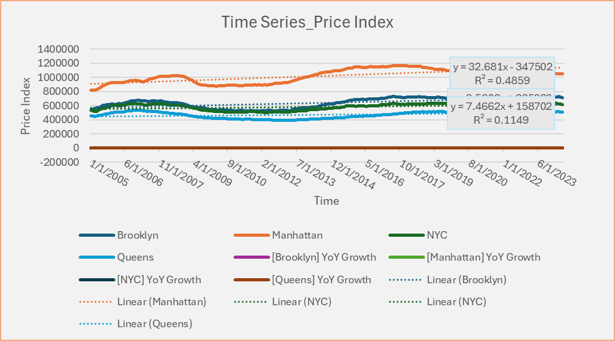

1. **Overall Trends**

All boroughs show a general upward trend in price indices over time, indicating long-term appreciation in real estate values. Manhattan consistently has the highest price index, followed by Brooklyn, then NYC overall, and Queens.

1. **Growth Rates**

Brooklyn has the steepest trendline slope (y = 8.5303x + 225860), suggesting it has experienced the fastest price growth over the period. Manhattan's trendline (y = 32.681x - 347502) shows a high rate of growth, but its R² value of 0.4859 indicates more volatility or deviation from the linear trend. Queens has the shallowest slope (y = 7.4662x + 158702), indicating slower price growth compared to other boroughs.

1. **Market Cycles**

There's a noticeable dip in all price indices around 2009-2010, likely reflecting the impact of the global financial crisis. Manhattan shows the most pronounced cycles, with clear peaks and troughs throughout the period.

1. **Recent Trends**

Manhattan's price index appears to be declining slightly in the most recent period, while Brooklyn and NYC overall continue to rise. Queens shows relatively stable prices in recent years with a slight upward trend.

1. **Convergence/Divergence**

The gap between Manhattan and other boroughs widened significantly from 2012 to 2017 but has been narrowing in recent years. Brooklyn's price index has been converging with the overall NYC index, especially since 2015.

1. **Volatility**

Manhattan exhibits the highest volatility, with larger swings in its price index. Queens shows the least volatility, with a more stable and gradual increase over time.

1. **R-squared Values**

The lower R² values (particularly for Manhattan and Queens) suggest that linear trendlines may not fully capture the price dynamics, indicating more complex patterns or external factors influencing prices.

### 

## **Year over Year Growth Rate**

This chart provides insights that complement the Price Index Time Series analysis:

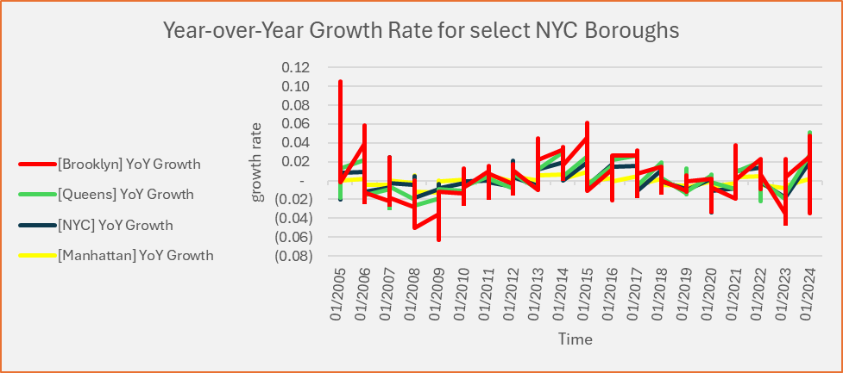

**Insights**

1. **Volatility**: The growth rates for all areas show significant volatility, with frequent swings between positive and negative growth. This volatility wasn't as apparent in the Price Index chart.
2. **Cyclical Patterns**: There appear to be cyclical patterns in growth rates, with periods of higher growth followed by slowdowns or negative growth.
3. **Divergence**: The growth rates for different areas often move in different directions, indicating that local factors may be influencing prices more than city-wide trends.
4. **Recovery Periods**: There are noticeable spikes in growth rates following periods of decline, possibly indicating recovery phases in the real estate market.
5. **Recent Trends**: Towards the end of the timeline, growth rates seem to be converging and showing less volatility, which might suggest a stabilizing market.

**Connection to Price Index Analysis**

The volatility in growth rates explains why the R-squared values in the Price Index trend lines were relatively low, especially for Manhattan and Queens. The periods of negative growth align with the dips observed in the Price Index chart, particularly around 2009-2010. Queens' more stable growth rate in recent years corroborates the steadier price index trend observed in the previous chart. Manhattan's higher volatility in growth rates is consistent with the larger swings seen in its price index.

## **Regression Analysis**

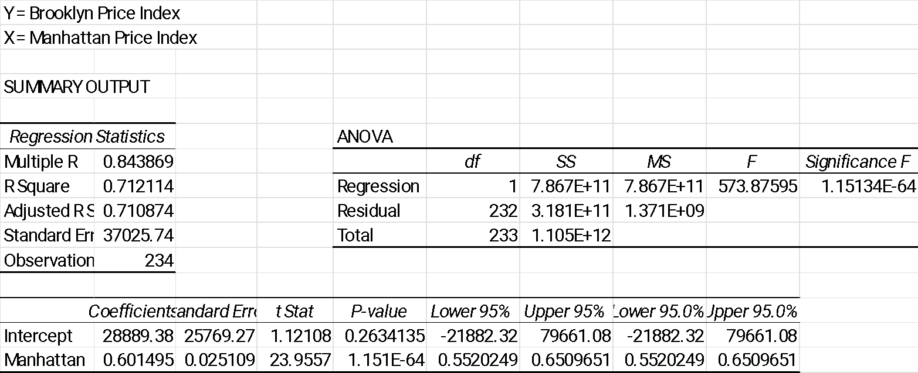

**Brooklyn and Manhattan Regression key components and insights**: This analysis supports the observations from the time series charts, showing a strong connection between Manhattan and Brooklyn real estate markets, while also highlighting that Brooklyn has its own unique factors influencing its price index.

1. **Correlation**

* Multiple R (0.843869) indicates a strong positive correlation between Brooklyn and Manhattan price indices.

1. **Model Fit**

* R Square (0.712114) suggests that about 71.21% of the variance in Brooklyn's price index can be explained by Manhattan's price index.
* Adjusted R Square (0.710874) is very close to R Square, indicating the model isn't overfitted

1. **Statistical Significance**

* The F-statistic (573.87595) and its corresponding Significance F (1.151E-64) show that the model is statistically significant at any reasonable significance level.

1. **Relationship**

* The coefficient for Manhattan (0.601495) indicates that for every 1 point increase in Manhattan's price index, Brooklyn's price index increases by about 0.6015 points.
* This relationship is highly statistically significant (P-value: 1.151E-64).

1. **Intercept**

* The intercept (28889.38) suggests that if Manhattan's price index were 0, Brooklyn's would be 28889.38.
* However, the intercept is not statistically significant (P-value: 0.2634135), so we shouldn't interpret it too strictly.

1. **Prediction Interval**

* The standard error (37025.74) indicates the average distance that the observed values fall from the regression line.

**Insights**

There's a strong positive relationship between Manhattan and Brooklyn price indices. Changes in Manhattan's real estate market significantly influence Brooklyn's market. The model has good predictive power, explaining over 71% of Brooklyn's price variations. While there's a strong relationship, other factors also influence Brooklyn's prices (accounting for the remaining ~29% of variance). The relationship is consistent and reliable, given the very low p-values. 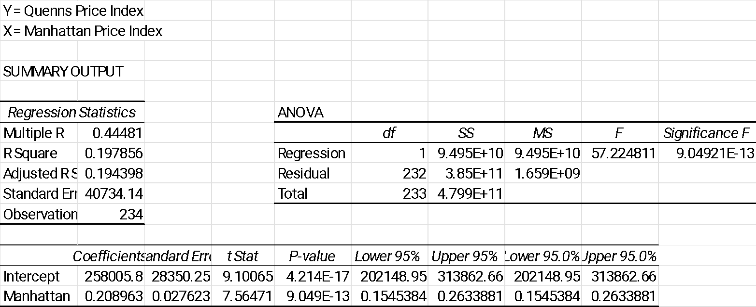

The regression between Queens Price Index (Y) and Manhattan Price Index (X):

1. **Correlation**:

* Multiple R (0.44481) indicates a moderate positive correlation between Queens and Manhattan price indices.

1. **Model Fit**

* R Square (0.197856) suggests that only about 19.79% of the variance in Queens' price index can be explained by Manhattan's price index.
* Adjusted R Square (0.194398) is very close to R Square, indicating the model isn't overfitted.

1. **Statistical Significance**

* The F-statistic (57.224811) and its corresponding Significance F (9.049E-13) show that the model is statistically significant, despite the low R Square.

1. **Relationship**

* The coefficient for Manhattan (0.208963) indicates that for every 1 point increase in Manhattan's price index, Queens' price index increases by about 0.209 points.
* This relationship is highly statistically significant (P-value: 9.049E-13).

1. **Intercept**

* The intercept (258005.8) is statistically significant (P-value: 4.214E-17), suggesting a substantial baseline for Queens' price index independent of Manhattan's influence.

1. **Prediction Interval**

* The standard error (40734.14) is relatively high, indicating considerable variability around the regression line.

**Insights**:

1. There's a positive but relatively weak relationship between Manhattan and Queens price indices.
2. Changes in Manhattan's real estate market have some influence on Queens' market, but it's much less pronounced than the influence on Brooklyn (from your previous regression).
3. The model has limited predictive power, explaining only about 20% of Queens' price variations.
4. A significant portion of Queens' price index (the intercept) seems independent of Manhattan's influence.
5. While statistically significant, the relationship is not as strong or reliable as the Manhattan-Brooklyn relationship.

**Comparison to Brooklyn Regression**

Queens' prices are much less influenced by Manhattan than Brooklyn's prices are. Queens' real estate market appears to have more independent factors driving its prices. The weaker relationship aligns with the observations from the time series charts, where Queens showed more stable and independent price trends.

This analysis suggests that while there is some connection between Manhattan and Queens real estate markets, Queens operates much more independently than Brooklyn does in relation to Manhattan. This could be due to factors such as different demographics, housing types, or local economic conditions in Queens.

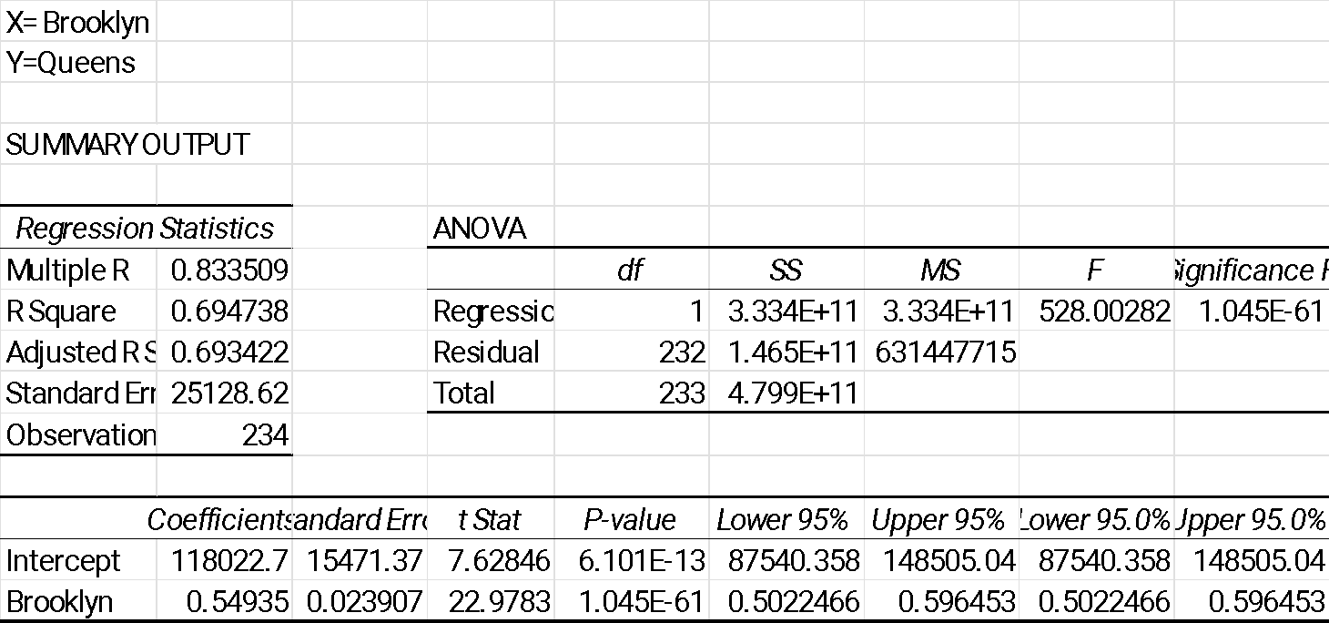

**Brooklyn (X) and Queens (Y) price indices regression analysis insights**

1. Correlation:

* Multiple R (0.833509) indicates a strong positive correlation between Brooklyn and Queens price indices.

2. Model Fit:

* R Square (0.694738) suggests that about 69.47% of the variance in Queens' price index can be explained by Brooklyn's price index.
* Adjusted R Square (0.693422) is very close to R Square, indicating the model isn't overfitted.

3. Statistical Significance:

* The F-statistic (528.00282) and its corresponding Significance F (1.045E-61) show that the model is highly statistically significant.

4. Relationship:

* The coefficient for Brooklyn (0.54935) indicates that for every 1 point increase in Brooklyn's price index, Queens' price index increases by about 0.549 points.
* This relationship is highly statistically significant (P-value: 1.045E-61).

5. Intercept:

* The intercept (118022.7) is statistically significant (P-value: 6.101E-13), suggesting a substantial baseline for Queens' price index independent of Brooklyn's influence.

6. Prediction Interval:

* The standard error (25128.62) is lower than in the Manhattan-Queens regression, indicating less variability around the regression line.

**Insights:**

1. There's a strong positive relationship between Brooklyn and Queens price indices, stronger than the Manhattan-Queens relationship but slightly weaker than the Manhattan-Brooklyn relationship.
2. Changes in Brooklyn's real estate market have a significant influence on Queens' market.
3. The model has good predictive power, explaining about 69.5% of Queens' price variations.
4. The relationship between Brooklyn and Queens prices is more balanced (coefficient closer to 0.5) compared to the Manhattan-Brooklyn relationship.
5. The relationship is highly consistent and reliable, given the very low p-values.

**Comparison to Brookly/Manhattan and Queens/Manhattan Regressions**:

1. Queens' prices are much more closely related to Brooklyn's prices than to Manhattan's.
2. The Brooklyn-Queens relationship is almost as strong as the Manhattan-Brooklyn relationship.
3. This suggests a "ripple effect" in pricing, where Manhattan influences Brooklyn, which in turn influences Queens.

**Limitation of Regression Analysis:**

1. The linear model captures only a small portion of the factors influencing prices.
2. There are likely many other important factors not accounted for in this simple regression.
3. Past relationships may not perfectly predict future trends, especially in changing market conditions.

# **Visualizations and Dashboard**s

## **Median Sales Price over Time**

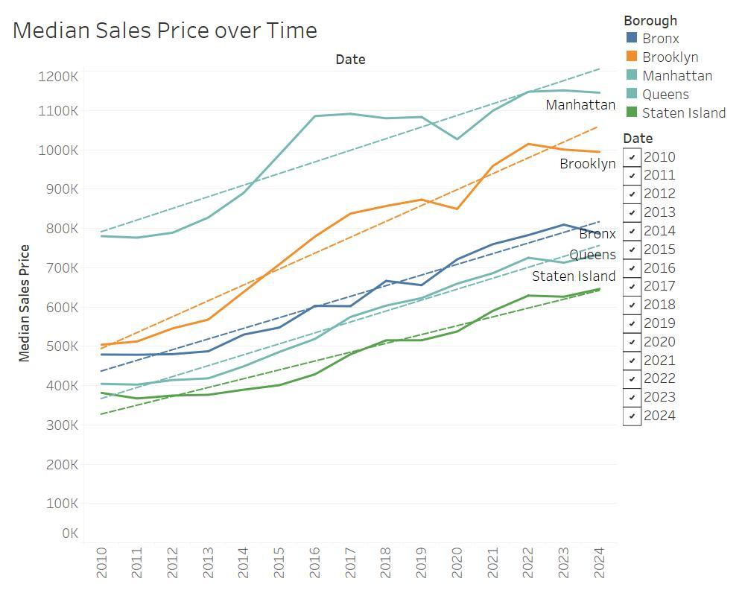

This line graph provides a comprehensive view of median sales price trends across all five boroughs of New York City from 2010 to 2024. Here's an analysis of the key insights:

1. Overall Trend: All boroughs show an upward trend in median sales prices over the 15-year period, indicating general appreciation in the NYC real estate market.
2. Borough Rankings:
   * Manhattan consistently has the highest median sales prices.
   * Brooklyn has overtaken Queens as the second most expensive borough around 2013-2014.
   * The Bronx and Staten Island generally have lower median prices but show steady growth.
3. Growth Rates:
   * Brooklyn shows the steepest price increase, especially from 2013 onwards.
   * Manhattan's growth is more volatile, with sharp increases and occasional dips.
   * Queens, the Bronx, and Staten Island show more gradual, steady growth.
4. Convergence/Divergence:
   * The gap between Manhattan and other boroughs widened significantly until around 2017-2018.
   * Brooklyn has been closing the gap with Manhattan in recent years.
   * The Bronx, Queens, and Staten Island seem to be converging in prices towards the end of the period.
5. Market Cycles:
   * There's a noticeable dip or slowdown in price growth across boroughs around 2019-2020, possibly reflecting the impact of the COVID-19 pandemic.
   * A sharp recovery and price acceleration is visible post-2020 for most boroughs.
6. Recent Trends:
   * Manhattan shows a slight decline in the most recent years, while Brooklyn continues to rise.
   * The Bronx, Queens, and Staten Island have maintained steady growth in recent years.

**Tying back to previous analyses**:

1. This graph aligns well with the earlier price index time series analysis, showing similar trends in borough rankings and growth patterns.
2. The strong performance of Brooklyn supports the regression analysis that showed a high correlation between Manhattan and Brooklyn prices.
3. The convergence of prices in the Bronx, Queens, and Staten Island in recent years might explain why the regression analysis showed a weaker relationship between Manhattan and Queens prices compared to Manhattan and Brooklyn.

## **Inventory Trend over Time**

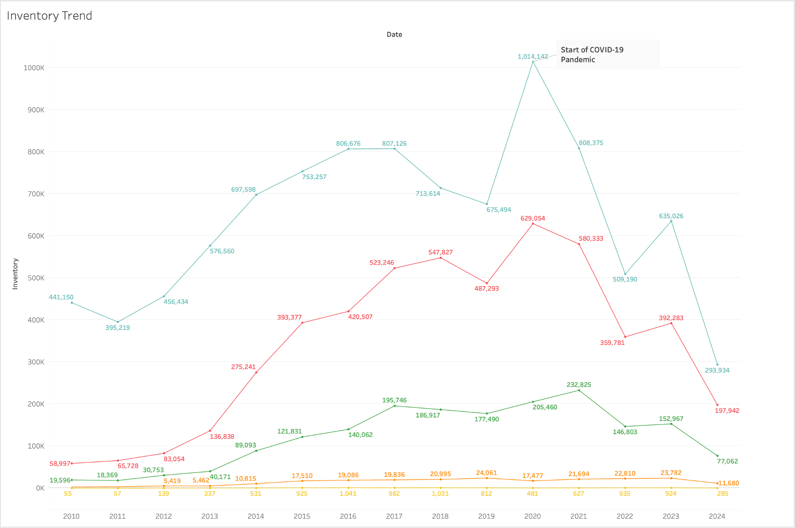

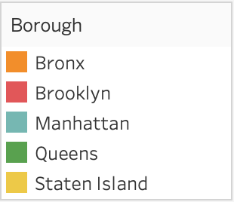

This inventory data adds a crucial dimension to our analysis, helping to explain some of the price trends and inter-borough dynamics we observed. It highlights the complex interplay between supply, demand, and external shocks (like the pandemic) in shaping the NYC real estate market.

Highlights:

1. Overall Trend: The inventory levels show significant fluctuations over time, with a notable peak around 2020 and a sharp decline afterwards.
2. COVID-19 Impact: The graph marks the start of the COVID-19 pandemic, which coincides with a dramatic spike in inventory. This aligns with the price dip we observed in 2019-2020 in the median sales price graph.
3. Post-Pandemic Recovery: After the COVID-19 peak, there's a sharp decline in inventory across all boroughs. This corresponds with the price acceleration we saw in the median sales price graph post-2020.
4. Borough-Specific Trends:
   * Manhattan (blue line) shows the highest volatility in inventory, mirroring its price volatility in the earlier analysis.
   * Brooklyn (red line) shows significant inventory growth up to 2020, which may have contributed to its rapid price appreciation.
   * Queens, Bronx, and Staten Island show more stable inventory levels, which aligns with their steadier price growth in the earlier analysis.
5. Recent Trends: The sharp decline in inventory across all boroughs in recent years could explain the continued price growth we observed, especially in Brooklyn and the outer boroughs.
6. Supply-Demand Dynamics: The inverse relationship between inventory levels and prices (high inventory in 2020 corresponding to price dips, low inventory post-2020 corresponding to price increases) illustrates the fundamental supply-demand dynamics in the real estate market.
7. Manhattan's Unique Pattern: Manhattan's inventory shows a distinct pattern, with a much higher peak and more dramatic fall. This could explain its more volatile price movements and recent slight decline in prices compared to other boroughs.

**Key Insights**

1. The current low inventory levels across all boroughs suggest continued upward pressure on prices, which aligns with the recent price trends we observed.
2. The pandemic's impact on inventory levels was significant but relatively short-lived, indicating the resilience of the NYC real estate market.
3. The relationship between inventory and prices underscores the importance of considering supply factors in addition to demand when analyzing real estate markets.

**Tying back to previous analyses**

The inventory trends provide context for the price movements we analyzed earlier. The sharp drop in inventory post-2020 likely contributed to the price acceleration we observed.

1. The divergence in inventory trends between boroughs (especially Manhattan vs. others) helps explain the changing relationships between borough prices that we noted in the regression analysis.ie back to the previous analysis:

## **Heat Map - Prices by Neighborhood**

We created a heatmap of all boroughs. This heat map (excerpt) provides insights into neighborhood price trends in the Bronx from 2020 to 2024. Highlights include:

1. Price Range: The Bronx shows a wide range of median sales prices, from around $600,000 to over $3 million, indicating significant variation between neighborhoods.
2. Top Neighborhoods: University Heights consistently stands out as the most expensive neighborhood, with median prices well above $2.8 million across all years.
3. Price Trends:
   * Most neighborhoods show fluctuating prices year-over-year, rather than steady increases.
   * Some areas like Castle Hill and City Island show significant price jumps in certain years (e.g., Castle Hill in 2022, City Island in 2024).
4. Stability: Neighborhoods like Longwood and Co-op City show relatively stable prices across the years, with gradual increases.
5. Variations: There's considerable variation in how different neighborhoods have performed. Some show clear upward trends (e.g., Morris Heights), while others fluctuate more unpredictably.

**Tying back to other analyses**:

1. **Regression Analysis**: The variability in price trends across neighborhoods supports the earlier finding that borough-level analyses (like the Manhattan-Bronx regression) may not capture the full picture. Neighborhood-specific factors clearly play a significant role.
2. **Borough Comparison**: This detailed view of the Bronx provides context for how it compares to other boroughs. While the Bronx generally has lower prices than Manhattan or Brooklyn, this heat map shows there are high-value areas within the borough.
3. **Price Index Trends**: The year-to-year changes in this heat map align with the observation from the price index analysis that there's considerable volatility in the NYC real estate market.
4. Top Neighborhoods: This view gives a more nuanced picture than just looking at the top most expensive neighborhoods across NYC (in the next section). It shows how even within a traditionally less expensive borough like the Bronx, there are significant price variations and high-value areas.Dashboard – Top Expensive Neighborhoods in NYC and Each Borough (2021-2024).

## **Dashboard - Top Expensive Neighborhoods - Each Borough and Overall**

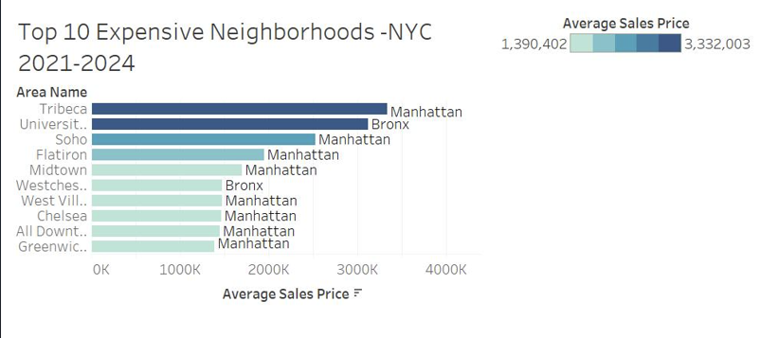

Note – no information on Staten Island neighborhoods was included in the data. Therefore, Staten Island was not included in the dashboard.

**Key Insights**

Manhattan dominates the list of most expensive neighborhoods in NYC, with 8 out of the top 10.

1. Tribeca is the most expensive neighborhood overall, with an average sales price over $3 million.
2. The Bronx has two neighborhoods in the top 10: University Heights (2nd overall) and Westchester Village (6th).
3. The price range for the top 10 neighborhoods spans from about $1.4 million to $3.3 million.

**Top neighborhood in each borough shown:**

1. Bronx: University Heights*
   * 2nd most expensive overall
   * Average sales price appears to be around $3 million
   * Significantly more expensive than other Bronx neighborhoods shown
2. Manhattan: Tribeca
   * Most expensive neighborhood in NYC
   * Average sales price over $3.3 million
3. Brooklyn: Not shown in top 10 list.
   * Most expensive neighborhood in Brooklyn is Carroll Gardens with averages sales price of $1.6Mil
4. Queens: Not shown in top 10 list.
   * Most expensive neighborhood in Queens is Brookville with average sales price approaching $1.3Mil.
5. Staten Island: Not shown in top 10 list

* This information is unexpected and needs to be examined in detail.

# **Limitation of Data**

The current dataset focusing primarily on sales prices and borough information has limitations in terms of providing a comprehensive view of the NYC real estate market. Here are some key factors that, if included, would significantly improve the analysis:

1. **Location**: Proximity to amenities, transit, and employment centers.
2. **Crime Rates**: Safety is a key consideration for homebuyers
3. **Economic Conditions**: Job market strength and overall economic health of the city.
4. **Housing Supply and Demand**: New construction rates vs. population growth.
5. **Interest Rates**: Affects affordability and investment decisions.
6. **Local Policies**: Rent regulations, tax policies, and zoning laws.
7. **Historical Context**: Including historical data from earlier periods alongside the current dataset from 2010 to 2024 would provide a longer-term perspective on market trends and cycles.
8. **Historical Context**: Including historical data from earlier periods alongside the current dataset from 2010 to 2024 would provide a longer-term perspective on market trends and cycles.
9. **Granular Demographic Data**: Detailed demographic information such as age distribution, household size, and migration patterns would help understand demand drivers and the impact of demographic shifts on the real estate market.
10. **Environmental Factors**: Data on environmental factors like flood zones, air quality, and proximity to parks and green spaces can significantly influence real estate values and should be included in a comprehensive analysis.

Incorporating additional data would provide a much better context for understanding price trends and neighborhood valuations in NYC's real estate market. It would allow for a more nuanced analysis, such as predicting future top neighborhoods or understanding the impact of policy changes on housing affordability and forecasting sales.

# **Stakeholder implicatons, comparisons to other markets, outlook, and conclusion**

## **Implications for Stakeholders**

For real estate investors, this analysis shows the importance of a strategic approach to investment. The variability in market performance across different boroughs suggests that investors should be cautious and conduct thorough due diligence before committing to significant investments. For homeowners and potential buyers, the current market conditions offer both opportunities and challenges. While low-interest rates might make home ownership more accessible, rising property values could limit affordability for many. Renters, on the other hand, may continue to face challenges related to affordability and availability, particularly in high-demand areas.

Policymakers also have a critical role to play in shaping the future of the NYC real estate market. The data suggests that targeted policies aimed at addressing issues such as affordable housing, gentrification, and housing supply could have a significant impact on the market’s trajectory. By implementing policies that balance the needs of various stakeholders, policymakers can help ensure a more equitable and sustainable real estate market in the city.

## **Comparison to Other Major Markets**

When comparing the NYC real estate market to other major cities such as Los Angeles, Chicago, and Miami, several unique characteristics stand out. Unlike some other cities, NYC’s market is heavily influenced by its status as a global financial center, leading to higher property values and greater demand for luxury housing. However, similar to these other markets, NYC is also grappling with challenges related to affordability, income inequality, and urban sprawl. By examining the similarities and differences between these markets, stakeholders can gain a deeper understanding of the factors driving NYC’s real estate trends and how they align with national or global patterns.

## **Future Outlook**

Looking ahead, the NYC real estate market is likely to continue evolving in response to both local and global forces. Economic conditions, such as the potential for a recession or changes in federal monetary policy, could significantly impact the market. Demographic shifts, including the migration patterns of millennials and the aging population, will also play a crucial role in shaping demand for different types of housing. Technological advancements, such as the rise of remote work and smart home technologies, may further influence buyer preferences and real estate values. By anticipating these trends, stakeholders can better position themselves to navigate the market's uncertainties and capitalize on emerging opportunities.

## **Conclusion**

The NYC real estate market shows robust overall growth with complex inter-borough dynamics, and presents both opportunities and challenges for stakeholders. Brooklyn's remarkable ascent, Manhattan's recent softening, and the steady growth in outer boroughs highlight the market's evolving nature. Future trends will likely be influenced by economic recovery, changing work patterns, and borough-specific development initiatives. The complexities of the market require ongoing research and analysis to ensure that decisions are based on the most up-to-date and accurate information available. Those looking for potential real estate transactions should Monitor Brooklyn's growth trajectory and its impact on overall market dynamics. Investigate factors behind Manhattan's recent price declines for potential market shifts, and explore investment opportunities in high-growth neighborhoods within traditionally lower-priced boroughs.

# 

# 

# 

# **References**

Long, G. (2017, July 27). Methodology: StreetEasy’s Price and Rent Indices. StreetEasy. <https://streeteasy.com/blog/methodology-price-and-rent-indices/>

M. J. Bailey, R. F. Muth and H. O. Nourse, “A Regression Method for Real Estate Price Index Construction,” Journal of the American Statistical Association, vol. 58, pp. 933-942, 1963.

K. E. Case and R. J. Shiller, “The Efficiency of the Market for Single Family Homes,” American Economic Review, vol. 79, pp. 125-137, 1989.

(n.d.). Trends in New York City Housing Price Appreciation. Trends in New York City Housing Price Appreciation. <https://furmancenter.org/research/publications/>

‌

‌